OAM(OFFICER INCHARGE IN ACADEMICS MATTER)
Name: Dr. Lellapalli Rithesh |  | 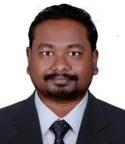 |  | DEPT.OF.AGRICULTURAL ECONOMICS
Designation: Assistant Professor Email I’d: rithesh132@gmail.com

OSA(OFFICER INCHARGE IN STUDENT AFFAIRS)
Name:Ms.K.Rajitha |  | 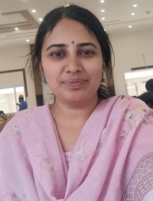 |  | DEPT.OF.BIOCHEMISTRY
Designation: Assistant Professor
EmailI’d: karivemularajitha@gmail.com

S.NO | FACULTY NAME AND DESIGNATION | PHOTO |  |  | DEPARTMENT
 |  |  |  |  | DEPT.OF.AGRONOMY
1. | Name: Sridhara MR |  | 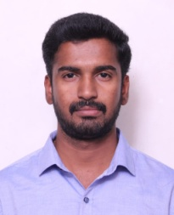  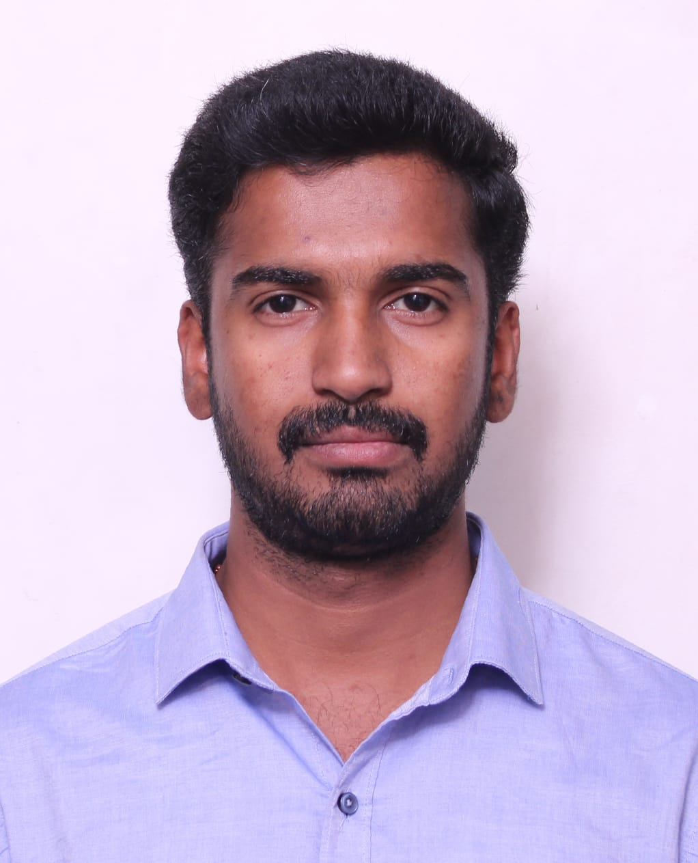 |  | DEPT.OF.AGRONOMY
1. | Designation: Assistant Professor
1. | EmailI’d:agrisridhar72@gmail.com
2. | Name: Dr.M.Siyon kumari | 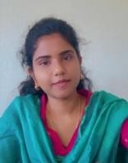 |  |  | DEPT.OF.AGRONOMY
2. | Designation: Assistant professor |  |  |  | DEPT.OF.AGRONOMY
2. | Emailid:kumarisiyon5@gmail.com |  |  |  | DEPT.OF.AGRONOMY
3. | Name: J. Krupa Amrutha | 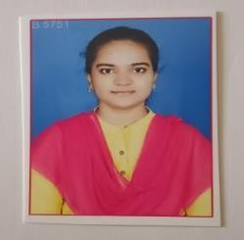 |  |  | DEPT.OF.AGRONOMY
3. | Designation: Assistant Professor |  |  |  | DEPT.OF.AGRONOMY
3. | EmailI’d:krupaamrutha786@gmail.com |  |  |  | DEPT.OF.AGRONOMY

S.NO | FACULTY NAME AND  DESIGNATION | PHOTO |  |  | DEPARTMENT
1. | Name: Dr.K.T.Rangaswamy |  | 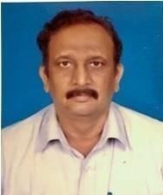
 | Designation: Professor
 | EmailI’d:9916063028
2. | Name: Lellapalli Rithesh |  | 
 | Designation: Assistant Professor |  |  |  | DEPT.OF.PLANT
 |  |  |  |  | PATHOLOGY
 | EmailI’d:rithesh132@gmail.com
 | Name: K.Mounika |  | 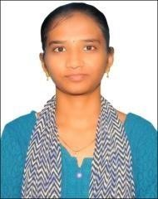
33 | Name: K.Mounika
3.
3. | Designation: Assistant Professor
3334 |  |  |  | 3
3  333 | EmailI’d:mounika.2k2@gmail.com

S.NO | FACULTY NAME AND  DESIGNATION | PHOTO |  |  | DEPARTMENT
1. | Name: Dr.L.P. Venkat Reddy |  | 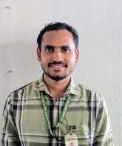 |  | DEPT.OF.PLANT ENTOMOLOGY
1. | Designation: Assistant Professor
1. | EmailI’d:venki.ag.25@gmail.com
2. | Name: K. Alekya |  | 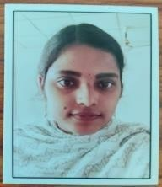 |  | DEPT.OF.PLANT ENTOMOLOGY
2. | Designation: Assistant Professor
2. | EmailI’d:  kakullaalekya22@gmail.com

S.NO | FACULTY NAME AND DESIGNATION | PHOTO |  |  | DEPARTMENT
 |  |  |  |  | DEPT.OF.GENETICS ANDPLANTBREEDING
2. | Name: Prem Sagar SP |  | 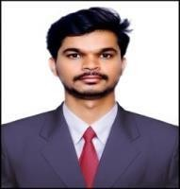 |  | DEPT.OF.GENETICS ANDPLANTBREEDING
2. | Designation:Assistant Professor
2. | EmailI’d:nspremsagar@gmail.com
3. | Name: S.Sreekanth | 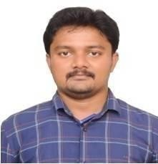 |  |  | DEPT.OF.GENETICS ANDPLANTBREEDING
3. | Designation: Assistant Professor |  |  |  | DEPT.OF.GENETICS ANDPLANTBREEDING
3. | EmailI’d:  srikanthsandu6732@gmail.com |  |  |  | DEPT.OF.GENETICS ANDPLANTBREEDING

S.NO | FACULTY NAME AND DESIGNATION | PHOTO |  |  | DEPARTMENT
1. | Name: Dr.B .Jaya Chandra reddy |  |  |  | DEPT.OF.SOILSCIENCE AND AGRICULTURAL CHEMISTRY
1. | Designation::Assistant Professor
1. | EmailI’d:boreddyssac@gmail.com
2. | Name: B.Suguna |  | 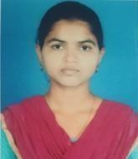 |  | DEPT.OF.SOILSCIENCE AND AGRICULTURAL CHEMISTRY
2. | Designation: Assistant Professor
2. | EmailI’d:  sugunabandaru99@gmail.com

S.NO | FACULTY NAME AND DESIGNATION | PHOTO |  |  | DEPARTMENT
1. | Name: Dr.MD.Shafi |  | 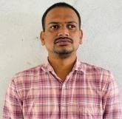 |  | DEPT.OF. AGRICULTURAL EXTENSION
1. | Designation:Assistant Professor  &NSSOfficer
1. | EmailI’d:  Shafiagri23@gmail.con
2. | Name: D. Bhagya Laxmi |  | 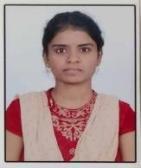 |  | DEPT.OF. AGRICULTURAL EXTENSION
2. | Designation: Assistant Professor
2. | EmailI’d:bl626873@gmail.com

S.NO | FACULTY NAME AND DESIGNATION | PHOTO |  |  | DEPARTMENT
1. | Name: Dr. T. Ravi Kumar |  | 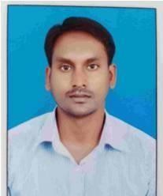 |  | DEPT.OF. HORTICULTURE
1. | Designation: Assistant Professor
1. | Email I’d: ravikumarveg13@gmail.com
2. | Name: Dr. N. Kowsalya |  | 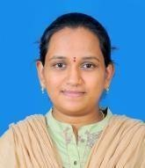 |  | DEPT.OF. HORTICULTURE
2. | Designation: Assistant Professor
2. | EmailI’d:  kowsalyanallapotala@gmail.com
3. | Name: Dr.Y.Gowthami |  | 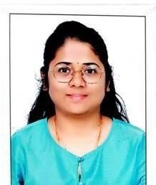 |  | DEPT.OF. HORTICULTURE
3. | Designation: Assistant Professor
3. | EmailI’d:  gouthuofficial@gmail.com

S.NO | FACULTY NAME AND DESIGNATION | PHOTO |  |  | DEPARTMENT
1.  2.22 | Name: Er.K. Revathi Yadav |  | 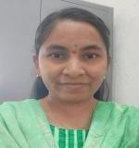 |  | DEPT.OF. AGRICULTURAL ENGINEERING
1.  2.22 | Designation::Assistant Professor
1.  2.22 | Email I’d: revathikommarla@gmail.com
1.  2.22 | 2222 |  |  |  | DEPT.OF. AGRICULTURAL ENGINEERING
2 2. | Name: Gali Hemanth kumar | 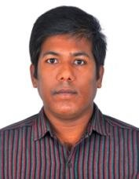 |  |  | DEPT.OF. AGRICULTURAL ENGINEERING
2 2. | Designation::Assistant Professor |  |  |  | DEPT.OF. AGRICULTURAL ENGINEERING
2 2. | Email  I’d:hemanthkumarniftem@gmail.com |  |  |  | DEPT.OF. AGRICULTURAL ENGINEERING

S.NO | FACULTYNAMEAND DESIGNATION | PHOTO |  |  | DEPARTMENT
1. | Name: Mr.SK. Yesdhanulla |  | 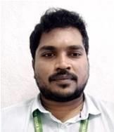 |  | DEPT.OF.AGRICULTURAL ECONOMICS
1. | Designation: Assistant Professor
1. | EmailI’d:  Yesdhanshaik79@gmail.com

S.NO | FACULTY NAME AND DESIGNATION | PHOTO |  |  | DEPARTMENT
1. | Name: Dr. M. Sreekanth |  | 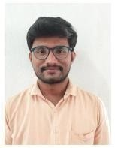 |  | DEPT.OF.CROP PHYSIOLOGY
1. | Designation::Assistant Professor
1. | EmailI’d:Srim2259@gmail.com

S.NO | FACULTY NAME AND DESIGNATION | PHOTO |  |  | DEPARTMENT
1. | Name: Ms.K. Rajitha |  |  |  | DEPT.OF. BIOCHEMISTRY
1. | Designation: Assistant Professor
1. | EmailI’d:  karivemularajitha@gmail.com

S.NO | FACULTY NAME AND DESIGNATION | PHOTO |  |  | DEPARTMENT
1. | Name: Mr.K.Naveen Kumar |  | 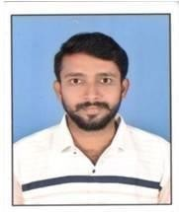 |  | DEPT.OF.MATH,STATISTIC &COMPUTERSCIENCE
1. | Designation::Assistant Professor
1. | EmailI’d:  naveenkrishnakuruva@gmail.com
2. | Name:Mrs.G.Malleshwari |  |  |  | DEPT.OF.MATH,STATISTIC &COMPUTERSCIENCE
2. | Designation: Assistant Professor
2. | EmailI’d:  gandlamalleswari774@gmail.com

S.NO | FACULTY NAME AND DESIGNATION | PHOTO |  |  | DEPARTMENT
1. | Name :Mrs.N.Jyothi |  | 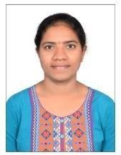 |  | DEPT.OF.ANIMAL SCIENCE
1. | Designation::Assistant Professor
1. | Email I’d: nagireddyjyo10@gmail.com

 | FACULTY NAME AND DESIGNATION | PHOTO |  |  | DEPARTMENT
1. | Name: BATNEPADU SUKANYA |  | 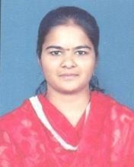 |  | DEPT.OF.PHYSICAL EDUCATION
1. | Designation: Physical director
1. | EmailI’d:sukanya.gtl2@gmail.com
2. | Name: YERRAGANGOLLA SREENIVASULU | 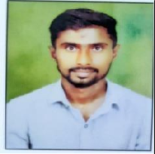 |  |  | DEPT.OF.PHYSICAL EDUCATION
2. | Designation: Physical director |  |  |  | DEPT.OF.PHYSICAL EDUCATION
2. | EmailI’d  :sreesreenivas1994@gmail.com |  |  |  | DEPT.OF.PHYSICAL EDUCATION

S.NO | FACULTY NAME AND DESIGNATION | PHOTO |  |  | DEPARTMENT
1. | Name:Mr.K.Ramalingaiah |  | 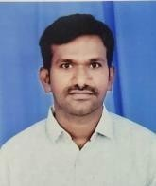 |  | DEPT.OF LIBRARY
1. | Designation::Assistant Professor
1. | EmailI’d:ramalinga14@gmail.com

