Demonstration trial on management of iron and potassium deficiency disorders in coconut (cocos nucifera)

Among the different nutrient deficiency disorders occurring in coconut, potassium and iron deficiency problems are very common as our soils are deficit in these two elements. Potassium is a major nutrient responsible for formation of sugars, carbohydrates, protein synthesis and cell division in plants, whereas iron is an essential micro nutrient that plants need to form chlorophyll and to complete photosynthesis besides playing essential role in many metabolic processes and energy transfer. The growth and yield of coconut are known to be more significantly impacted by deficiencies of these two elements.
A demonstration trial on management of potassium & iron deficiency disorders was conducted on road side planted hybrid coconut plants at J C Diwakar Reddy Agricultural College campus, Tadipatri, showing characteristics visible symptoms of iron and potassium deficiencies. Coconut plants with iron deficiency were identified based on symptoms such as yellowing of emerging leaves followed by leaf necrosis and turning completely white (fig:1 & 2), where as plants with potassium deficiency were found associated with symptoms viz., marginal chlorosis of lower leaves followed by brownish discoloration and drying from their margins (fig-4 & 5).
In order to demonstrate the management of the deficiency disorders using appropriate supplements, the coconut plants of three years old treated separately by supplementing respective nutrients. Muriate of potash was applied to the soil at the rate of 250g/plant to supplement potash and ferrous sulphate (FeSO₄) as a foliar spray at a concentration of 0.05% to supplement iron. The treated plants were observed for symptoms recovery.
The treated plants completely recovered from the disorders and produced normal leaves after a period of a month from the day of treatments (figs-3 & 6).
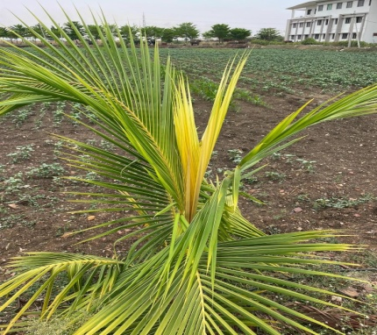 | 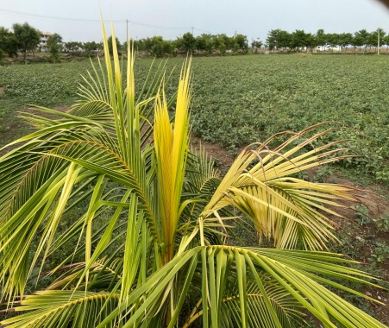 | 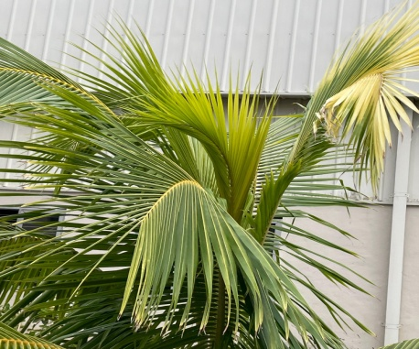
Fig-1 | Fig-2 | Fig-3
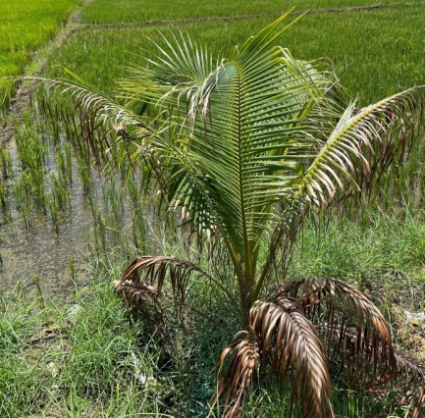 | 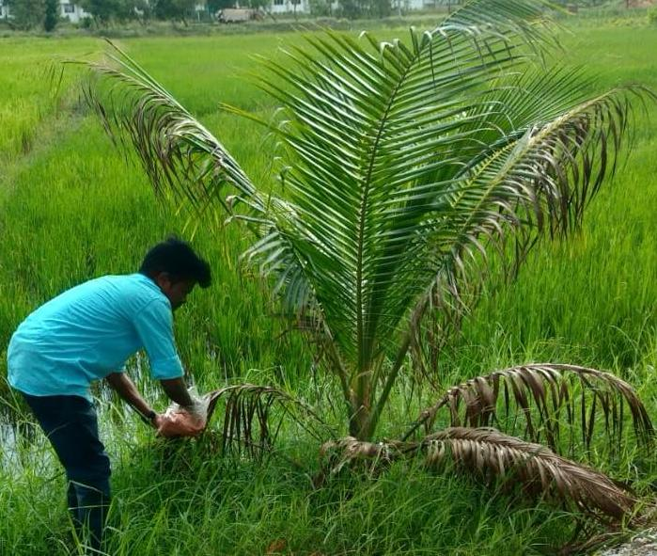 | 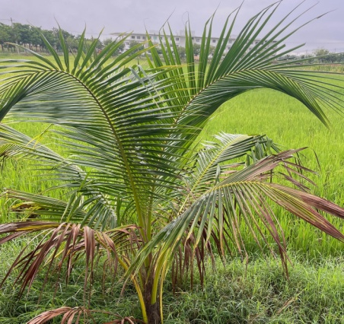
Fig-4 | Fig-5 | Fig-6
Coconut plants showing symptoms of iron (Fig-1 & 2) and potassium (Fig-4 & 5) deficiency and their recovery (Fig-3 & 6) after treatments.

The demonstration trials indicate that the potassium and iron deficiency disorders can be managed if they are properly detected and timely treatments are given to the affected plants using appropriate supplements that provide the required elements.

Scientists involved
1. Dr. K T Rangaswamy, Prof. of Plant Pathology
2. Mr. Manjunath S Shatoji, Asst. Prof of Plant Physiology

